## Oak-Conifer Forest and Woodland (OCFW)

### General Information

### Cover Type Overview

**Oak-Conifer Forest and Woodland (OCFW)**

* 60,457.06 acres / 244,66.14 hectares
* Crosswalks
  + EVeg: Regional Dominance Type 1
    - Black Oak
    - Eastside Pine, Jeffrey Pine, Ponderosa Pine
      * EVeg: Regional Dominance Type 2
        + Black Oak
        + Canyon Live Oak
        + Huckleberry Oak
        + Madrone
        + Montane Mixed Hardwood
        + Scrub Oak
        + Tanoak (Madrone)
  + LandFire BpS Model: 0610300 Mediterranean California Lower Montane Black Oak-Conifer Forest and Woodland
  + Presettlement Fire Regime Type: Yellow Pine
* Ultramafic
  + This modifier is created by intersecting an ultramafic soils/geology layer with the existing vegetation layer. Where cells intersect with OCFW they are assigned to the ultramafic modifier.

**Oak-Conifer Forest and Woodland with Aspen (OCFW-ASP)**

* 2.00 acres / 0.81 hectares
* This type is created by overlaying the NRIS TERRA Inventory of Aspen on top of the EVeg layer. Where it intersects with OCFW it is assigned to OCFW-ASP.

### Vegetation Description

**Oak-Conifer Forest and Woodland (OCFW)** The oak-conifer forest and woodland landcover type is characterized by woodlands or forests of *Pinus ponderosa* with one or more oaks, such as *Quercus kelloggii*, *Quercus garryana*, *Quercus wislizeni*, or *Quercus chrysolepsis*. *Pseudotsuga menziesii* and other conifer species are uncommon but may co-occur, especially after long-term fire suppression (LandFire 2007a) *Pinus jeffreyi* may occur on ultramafic sites (Fitzhugh 1988). In some areas, sites are dominanted initally by oaks, which form a dense subcanopy. Eventually, and especially on locally mesic sites, conifers will form a persistent emergent canopy over the oak (LandFire 2007a). In other cases, characteristic species occur in a mosaic-like pattern with small pure stands of conifers interspersed with small stands of broad-leaved trees. Most of the broad-leaved trees are schlerophyllous evergreen, but winter-deciduous species also occur (Anderson 1988). The understory is composed of shrubs such as *Arctostaphylos, Ceanothus, Chamaebatia, Cornus, Eriodictyon, Garrya, Prunus, Rhamnus, Ribes,* and *Toxicodendron diversilobum*. Grasses and forbs are diverse and include *Bromus, Melica, Poa, Elymus, Carex, Collinsia, Saltugilia, Iris, Lupinus, Streptanthus, Viola,* and *Pteridium aquilnum* (LandFire 2007a; Fitzhugh 1988)*.*

* **Ultramafic Modifier** *P. ponderosa* woodlands occur mainly on low-elevation ultramafics. They grow on strongly serpentinized soil, and they are in the vicinity of *P. ponderosa-Q. kelloggii* woodland that grows on deep, nonultramafic soil. While *P. ponderosa* dominates, it is associated with *Calocedrus decurrens, Pinus attentuata, Pinus lambertiana, P. sabiniana*, and *Q. chysolepis*. The shrub layer is dominated by *Arctostaphylos, Ceanothus, Eriodictyon, Heteromeles, Pickeringia*. The herb layer is a mix of sparse perennials and many annual grasses and forbs (O’Geen et al 2007: 97).

**Oak-Conifer Forest and Woodland with Aspen (OCFW-ASP)** When *P. tremuloides* co-occurs with OCFW on the west side of the crest, it is typically found in smaller patches, often less than 2 ha (5 acres) in size. Mature stands in which *P. tremuloides* are still dominant are usually relatively open. Average canopy closures of stands in eastern California range from 60 to 100 percent in young and intermediate-aged stands and from 25 to 60 percent in mature stands. The open nature of the stands results in substantial light penetration to the ground (Verner 1998).

### Distribution

**Oak-Conifer Forest and Woodland**  This type occurs in the valleys and lower slopes of mountainous terrain, on a variety of parent materials including granitics, metamorphic and Franciscan metasedimentary parent material and deep, well developed soils. Slopes are generally steep and all aspects are included. In the northern Sierra Nevada the elevational range is 240 to 1800 m (800 to 5000 ft) (LandFire 2007a, Anderson 1988).

* **Ultramafic Modifier**  Ultramafics have been mapped at various spatial densities throughout the elevational range of the Sierran Mixed Conifer landcover type. Low to moderate elevations in ultramafic and serpentinized areas often produce soils low in essential minerals like calcium potassium, and nitrogen, and have excessive accumulations of heavy metals such as nickel and chromium. These sites vary widely in the degree of serpentinization and effects on their overlying plant communities (“CalVeg Zone 1” 2011). Typically, this type occurs on north facing concave slopes or toe slopes with thin layers of ultramafic rocks. Note, the terms “ultramafic rock” and “serpentine” are broad terms used to describe a number of different but related rock types, including serpentinite, peridotite, dunite, pyroxenite, talc and soapstone, among others (Barbour et al. 2007).

**Oak-Conifer Forest and Woodland with Aspen** Sites supporting *P. tremuloides* are maintained by stand replacing disturbances that allow regeneration from below-ground suckers. Upland clones are impaired or eliminated by conifer ingrowth and overtopping and intenstive grazing that inhibits growth. If aboveground *P. tremuloides* on upland sites disappears completely (site overtaken by conifers) due to prolonged absence of disturbance, then restoration to a *P. tremuloides* condition is not a viable pathway. In a reference condition scenario, a few stands will advance toward conifer dominance, but in the current landscape scenario where fire has been reduced from reference conditions there are many more conifer-dominated mixed aspen stands (Verner 1998).

For aspen, Van de Water and Safford (2011) found a mean fire return interval of 19 years, median of 20 years, mean min interval of 10 years and mean max of 90 years. The LandFire model for northern Sierra Nevada aspen that is seral to conifers generated a mean return interval of 94 years for high mortality fire, 58 years for low mortality fire, and 36 years overall (LandFire 2007b).

**Disturbances**

### Wildfire

**Oak-Conifer Forest and Woodland** Wildfires are common and frequent; mortality depends on vegetation vulnerability and wildfire intensity. Low-mortality fires kill small trees and consume above-ground portions of shrubs and herbs, but do not kill large trees or below-ground organs of most shrubs and herbs which promptly re-sprout. High-mortality fires kill large as well as small trees, and may kill many of the shrubs and herbs as well. Fire kills the above- ground portions of the shrubs and herbs, but most shrubs and herbs promptly re-sprout from surviving below-ground organs. Wildfires may trigger transitions between developmental stages.

*P. ponderosa*-*Q. kelloggii* forests are fire-adapted and had frequent, low-severity surface fires prior to fire exclusion in the late nineteenth century. Historically, fire return intervals in *P. ponderosa*-*Q. kelloggii* forests increased with increasing elevation in the Sierra Nevada, with a tendency towards shorter mean fire return intervals (5-15 years) on dry, west- and south-facing slopes and longer fire-return intervals (15-25 years) on mesic, east- and north-facing slopes. Mid-elevation forests typically had mixed-severity fires that created patchy mosaics (Fryer 2007).

According to Fryer, fire-return intervals for *P. ponderosa* forests with a *Q. kelloggii* component ranged from 6 to 22 years in the Cascade Range of southern Oregon and northern California (2007). Skinner and Chang’s fire regime review paper (1996) included a study on Black oak-ponderosa pine vegetation in the Central Sierra in which the Median FRI was 8 years, with a minimum of 2 years and a maximum of 18 years. Another study on canyon live oak-mixed conifer vegetation also found evidence of frequent presettlement fire: median FRI was 11 years, with a minimum FRI of 7 years and a maximum of 33 years. The analogous presettlement fire regime for Van de Water and Safford (2011) to the YHR type is Yellow pine, which has a mean FRI of 11 years, a median of 7, a mean min of 5, and a mean max of 40. LandFire’s Mediterranean California Lower Montane Black Oak-Conifer Forest and Woodland for the northern Sierra notes that historical fire frequency was 5-30 years in this type. Modelers estimate an average fire intervals of 180 years for replacement fire, with a minimum of 100 years and a maximum of 300 years. For “mixed” fire, the average given is 50 years, with a minimum of 50 years and a maximum of 200 years. For surface fire, the average fire interval is 9 years, with a minimum of 5 years and a maximum of 30 years (2007a). We recalculated these numbers using condition-specific information and using only high and low mortality fire categories, which resulted in an interval of 55 years for high mortality fire, 8 years for low mortality fire, and 7 years for any fire.

* **Ultramafic Modifier** The LandFire model for Klamath-Siskiyou Lower Montane Serpentine Mixed Conifer Woodland (2007c) gave an overall average FRI of 10 years. Most fires are predicted to be low mortality surface fires occurring frequently, about every 12 years ranging from 3-35 years. High mortality fires were modeled to recur between 100 and 400 years, with an average FRI of 250 years. The LandFire model for Klamath-Siskiyou Xeromorphic Serpentine Savannah and Chaparral (2007d) estimates an overall average FRI of 14 years. Replacement fire has an average FRI of 200 years with a minimum of 100 years and maximum of 300 years, while surface fire has an average FRI of 15 years with a minimum of 10 years and a maximum of 20 years.

**Oak-Conifer Forest and Woodland with Aspen** Sites supporting *P. tremuloides* are usually associated with added soil moisture, i.e., azonal wet sites. These sites are often close to streams and lakes. Other sites include meadow edges, rock reservoirs, springs and seeps. Terrain can be simple to complex. At these lower elevations, topographic conditions for this type tends toward positions resulting in relatively colder, wetter conditions within the prevailing climate, e.g., ravines, north slopes, wet depressions, etc. (Landfire 2007b).

Table 1. OCFW, OCFW-ASP Fire return intervals (years) and percentage of high versus low mortality fires in relation to soil type modifier and the presence of *P. tremuloides* (Aspen). Values for OCFW were derived from BpS model 0610300 (Landfire 2007a) and Van de Water and Safford (2011). Values for OCFW on ultramafic soils were derived from BpS model 0610210 (Landfire 2007c). Numbers for OCFW-ASP were derived from BpS model 0610610 (Landfire 2007b) and Van de Water and Safford (2011).

|  |  |  |  |  |  |  |
| --- | --- | --- | --- | --- | --- | --- |
| **Variant** | **Modifier** | **Fire Severity** | **Average** | **Min** | **Max** | **% of Fires** |
| OCFW | None | High | 55 |  |  | 13 |
| Low | 8 |  |  | 87 |
| All Fires | 7 | 5 | 40 |  |
| Ultramafic | High | 250 |  |  | 18 |
| Low | 40 |  |  | 82 |
| All Fires | 30 | 4 | 157 |  |
| OCFW-ASP | n/a | High | 99 |  |  | 37 |
| Low | 58 |  |  | 63 |
| All Fires | 20 | 5 | 90 |  |

### Other Disturbance

Other disturbances are not currently modeled, but may, depending on the condition affected and mortality levels, reset patches to early development, maintain existing stages, or shift/accelerate succession to a more open stage. All of the tree species associated with this vegetation type are susceptible to a wide variety of pathogens and insects.

### Vegetation Condition Classes

### Oak-Conifer Forest and Woodland Variant

### Early Development (ED)

**Description** The early stage is the initial post-disturbance community dominated by coppicing oak sprouts (such as *Q. kelloggi* or *Q. chrysolepsis*). *T. diversilobum* may be abundant. Bunchgrasses and associated forbs dominate understory. Localized native herbivory may maintain oak sprouts in “shrub” form for extended period. Early stage includes oak sprouts or conifer seedling/saplings growing to 4-6” DBH (LandFire 2007a).

On sites or areas that are dry or of low quality, significant pine regeneration may depend on concurrent disturbance of chaparral and a good pine seed crop with favorable weather. Thus, it may require 50-100 years for significant pine regeneration in the absence of intervention. Clearcuts with minimal brush control develop a dense stand of pole-size trees in 20-30 years, twice the time required when brush is completely removed. Dense brush is typical in young stands and an herbaceous layer may develop on some sites. On drier sites, there is less tendency for succession toward shade-adapted species. As young, dense stands age and attain a closed canopy, they exclude most undergrowth. When other adapted conifers occur in moist pine stands of medium to high site quality, they may form a significant understory in about 20 years in the absence of fire (Fitzhugh 1988).

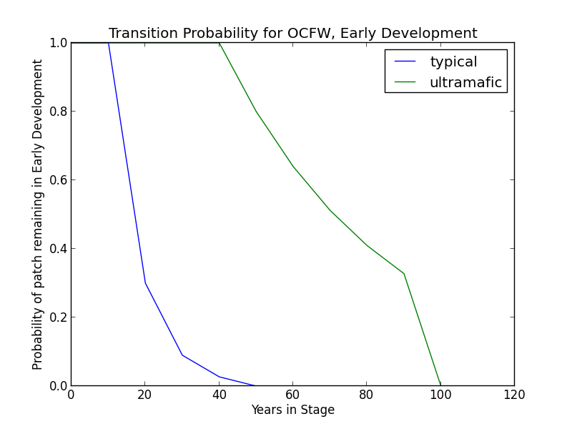**Succession Transition** In the absence of disturbance, this condition will begin transitioning to a mid development stage after 20 years. The probability of succession per time step is 0.7. The transition may be to either MDC or MDO. The secondary probability of succession to MDO is 0.9 and to MDC is 0.1. At 50 years, all stands will have succeeded to either MDC or MDO.

* **Ultramafic Modifier** Succession may be substantially delayed. Thus, in the absence of disturbance, this condition will begin transitioning to MDO after 50 years and may be delayed in the ED stage for as long as 100 years. A stand in this condition has a probability of 0.2 that it will succeed.

**Wildfire Transition** High mortality wildfire (100% of fires) recycles the patch through the Early Development stage. Low mortality wildfire is not modeled for this stage.

### Mid Development - Open (MDO)

**Description** The mid-seral, open stage has hardwoods dominating the canopy and may have sporadic conifer presence at low coverage levels. Oaks are pole-sized to very large. Bunchgrasses and shade-intolerant shrubs, most notably, will be prominent on the majority of sites. This condition is distinguished from MDC primarily by its reduced conifer presence.

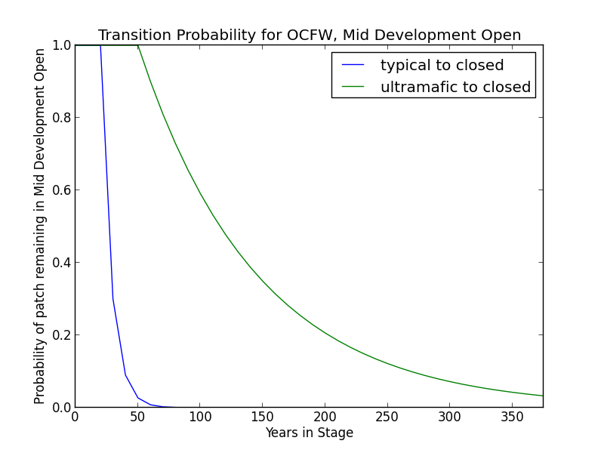**Succession Transition** This condition will maintain under low mortality disturbance, but after 30 years without fire it begins transitioning to MDC with a probability of succession of 0.7 per timestep.

* **Ultramafic Modifier** In the absence of low mortality disturbance, patches will begin transitioning to MDC after 60 years at a rate of 10%.

**Wildfire Transition** High mortality wildfire (3.8% of fires) recycles the patch through the Early Development stage. Low mortality wildfire (96.2%) maintains the patch in MDO.

### Mid Development - Closed (MDC)

**Description** The mid-seral, closed stage occurs at the more mesic end of the environmental gradient and supports a dense canopy of oak and *P. ponderosa* and/or *P. menziesii*. Oaks are still in the pole to medium size stage with crown closure approaching 70%. Conifers are generally medium to large, depending on stand age. Overall canopy cover is at least 50%. Sod-forming grasses and shade-tolerant shrubs will be prominent on the majority of sites. Species from more arid sites may be remnants of earlier, more open post-fire communities. This stage is distinguished from MDO primarily by its support of greater numbers of conifer species.

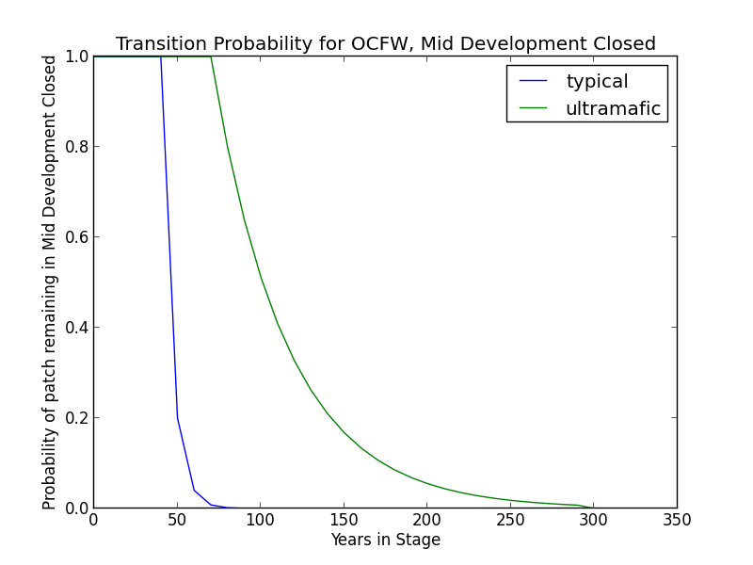**Succession Transition** In the absence of disturbance, this condition will begin transitioning to LDC after 50 years in MDC. The probability of succession per timestep is 0.8.

* **Ultramafic Modifier** Transition to late seral conditions may be substatially delayed. Thus, in the absence of disturbance, this condition will begin transitioning to LDC after 80 years at a rate of 20% per time step and may be delayed in the MDC stage for up to 150 years.

**Wildfire Transition** High mortality wildfire (4.7% of fires) recycles the patch through the Early Development stage. Low mortality wildfire (95.3%) triggers a transition to MDO 12.7% of the time; otherwise the patch remains in MDC.

### Late Development - All (LDA)

**Description** The late-seral condition occurs when fire has been excluded from a patch for an extended period of time. Oaks are being overtopped by conifers, especially shade-tolerant conifers such as *P. menziesii*. Thus, in this condition, oaks and even pines comprise a smaller proportion of the stand. Oaks and conifers are mature and large.

**Succession Transition** In the absence of transition-causing disturbance, this condition will maintain.

**Wildfire Transition** High mortality wildfire (4% of fires) recycles the patch through the early development stage. Low mortality wildfire (96%) maintains the patch in LDA.

**Aspen Variant**

**Early Development – Aspen (ED–A)**

**Description** Grasses, forbs, low shrubs, and sparse to moderate cover of tree seedlings/saplings (primarily *P. tremuloides*) with an open canopy. This condition is characterized by the recruitment of a new cohort of early successional, shade-intolerant tree species into an open area created by a stand-replacing disturbance.

Following disturbance, succession proceeds rapidly from an herbaceous layer to shrubs and trees, which invade together. *P. tremuloides* suckers over 6ft tall develop within about 10 years (LandFire 2007b).

**Succession Transition** Unless it burns, a patch in the early stage persists for 10 years, at which point it transitions to MDC-A.

**Wildfire Transition** High mortality wildfire (100% of fires) recycles the patch through the Early Development – Aspen stage. Low mortality wildfire is not modeled for this stage.

**Mid Development – Aspen (MD–A)**

**Description** *P. tremuloides* trees 5-16in DBH. Canopy cover is highly variable, and can range from 40-100%. These patches range in age from 10 to 150 years and could maintain indefinitely. Some understory conifers, like *P. ponderosa* or *P. menziesii* are encroaching, but *P. tremuloides* is still the dominant component of the stand (Landfire 2007b).

**Succession Transition** MD-A persists for at least 50 years in the absence of fire, after which stands begin transitioning to MD-AC at a rate of 0.7 per timestep. At age 100 all remaining MD-A patches transition to MD-AC.

**Wildfire** **Transition** High mortality wildfire (100% of fires) recycles the patch through the Early Development – Aspen stage. Low mortality wildfire is not modeled for this stage.

**Mid Development – Aspen with Conifer (MD–AC)**

**Description** These stands have been protected from fire for at least 100 years. *P. tremuloides* trees are predominantly 16in DBH and greater. Conifers are present and overtopping the *P. tremuloides*. *P. menziesii* is a typical conifer that is successional to *P. tremuloides*, and is depicted here, but other conifers like *P. ponderosa* are also possible. Conifers are pole to medium-sized, and conifer cover is at least 40% (Landfire 2007b).

**Succession Transition** MD-AC persists for 100 years in the absence of fire, after which stands transition to LDC.

**Wildfire Transition** High mortality wildfire (28.4% of fires) returns the patch to ED-A. Low mortality wildfire (71.6%) maintains the patch in MD- AC.

**Late Development – All (LDA)**

**Description** Some *P. tremuloides* continue to be present in the understory, but large conifers are now the dominant tree species, having overtopped the *P. tremuloides.* Smaller conifers are present in the midstory as well. Conifer species likely present include *P. ponderosa,* and *P. menziesii* (Landfire 2007b).

**Succession Transition** See description of same stage under Oak-Conifer Forest and Woodland Variant

**Wildfire Transition** High mortality wildfire (31.2% of fires) will return the patch to Early Development - Aspen. Low mortality wildfire (68.8%) maintains the current condition.

**Condition Classification**

Table 2. Classification of cover condition for OCFW. Diameter at Breast Height (DBH) and Cover From Above (CFA) values taken from EVeg polygons. DBH categories are: null, 0-0.9”, 1-5.9”, 5-9.9”, 10-19.9”, 20-29.9”, 30”+. CFA categories are null, 0-10%, 10-20%, … , 90-100%. Each row in the table below should be read with a boolean AND across each column of a row.

|  |  |  |  |  |  |
| --- | --- | --- | --- | --- | --- |
| Cover Condition | Overstory Tree  Diameter 1 (DBH) | Overstory Tree  Diameter 2 (DBH) | Total Tree  CFA (%) | Conifer  CFA (%) | Hardwood  CFA (%) |
| Early All | null | null | any | any | any |
| Early All | 0-4.9” | 0-4.9” | any | any | any |
| Early All | 0-4.9” | null | any | any | any |
| Mid Open | 0-4.9” | 5-29.9” | <50 | any | any |
| Mid Open | 5-29.9” | null | <50 | any | any |
| Mid Open | 5-29.9” | null | null | <50 | any |
| Mid Open | 5-29.9” | null | null | null | <70 |
| Mid Open | 5-29.9” | 0-29.9” | <50 | any | any |
| Mid Open | 5-29.9” | 0-29.9” | null | <50 | <70 |
| Mid Closed | 0-4.9” | 5-29.9” | >50 | any | any |
| Mid Closed | 5-29.9” | null | >50 | any | any |
| Mid Closed | 5-29.9” | null | null | >50 | any |
| Mid Closed | 5-29.9” | null | null | any | >70 |
| Mid Closed | 5-29.9” | 0-29.9” | >50 | any | any |
| Mid Closed | 5-29.9” | 0-29.9” | null | >50 | any |
| Mid Closed | 5-29.9” | 0-29.9” | null | any | >70 |
| Late All | 40”+ | any | any | any | any |
| Late All | any | 40”+ | any | any | any |

Table 3. Classification of cover condition for OCFW-ASP. Diameter at Breast Height (DBH) and Cover From Above (CFA) values taken from EVeg polygons. DBH categories are: null, 0-0.9”, 1-5.9”, 5-9.9”, 10-19.9”, 20-29.9”, 30”+. CFA categories are null, 0-10%, 10-20%, … , 90-100%. Each row in the table below should be read with a boolean AND across each column of a row.

|  |  |  |  |  |  |
| --- | --- | --- | --- | --- | --- |
| Cover Condition | Overstory Tree  Diameter 1 (DBH) | Overstory Tree  Diameter 2 (DBH) | Total Tree  CFA (%) | Conifer  CFA (%) | Hardwood  CFA (%) |
| Early All | 0-4.9” | any | any | any | any |
| Mid Aspen | 5-9.9” | any | null | null | null |
| Mid Aspen | 5-9.9” | any | <50 | any | any |
| Mid Aspen-  Conifer | 10-19.9” | any | >50 | any | any |
| Mid Aspen-  Conifer | 10-19.9” | any | null | >50 | any |
| Late Closed | 20”+ | any | >50 | any | any |
| Late Closed | 20”+ | any | null | >50 | any |
| Fire-Maintained  Aspen-Conifer | 20”+ | any | null | null | null |
| Fire-Maintained  Aspen-Conifer | 20”+ | any | <50 | any | any |

**Draft Model**

(See PDF) Disturbance-Succession model for OCFW and OCFW-ASP

**References**

O’Geen, Anthony T., Dahlgren, Randy A., and Sanchez-Mata, Daniel. “California Soils and Examples of Ultramafic Vegetation.” Barbour, Michael, Keeler-Wolf, Todd, and Schoenherr, Allan A., eds. *Terrestrial Vegetation of California, 3rd Edition*. 2007. pp. 71-106.

Anderson, Richard. “Montane Hardwood-Conifer (MHC).” *A Guide to Wildlife Habitats of California*. 1988. Mayer, Kenneth E. and Laudenslayer, William F., eds. California Deparment of Fish and Game. <http://www.dfg.ca.gov/biogeodata/cwhr/pdfs/MHC.pdf>. Accessed 4 December 2012.

“CalVeg Zone 1.” Vegetation Descriptions. *Vegetation Classification and Mapping*. 11 December 2008. U.S. Forest Service. <http://www.fs.usda.gov/Internet/FSE_DOCUMENTS/fsbdev3_046448.pdf>. Accessed 2 April 2013.

Fitzhugh, E. Lee. “Ponderosa Pine (PPN).” *A Guide to Wildlife Habitats of California*. 1988. Mayer, Kenneth E. and Laudenslayer, William F., eds. California Deparment of Fish and Game. <http://www.dfg.ca.gov/biogeodata/cwhr/pdfs/PPN.pdf>. Accessed 4 December 2012.

Fryer, Janet L. 2007. *Quercus kelloggii*. In: Fire Effects Information System. U.S. Department of Agriculture, Forest Service, Rocky Mountain Research Station, Fire Sciences Laboratory (Producer). <http://www.fs.fed.us/database/feis/plants/tree/quekel/all.html>. Accessed 21 December 2012.

LandFire. “Biophysical Setting Models.” Biophysical Setting 0610300. Zone 6. 2007a. LANDFIRE Project, U.S. Department of Agriculture, Forest Service; U.S. Department of the Interior. <http://www.landfire.gov/national_veg_models_op2.php>. Accessed 9 November 2012.

LandFire. “Biophysical Setting Models.” Biophysical Setting 0610610. 2007b. LANDFIRE Project, U.S. Department of Agriculture, Forest Service; U.S. Department of the Interior. <http://www.landfire.gov/national_veg_models_op2.php>. Accessed 7 January 2013.

LandFire. “Biophysical Setting Models.” Biophysical Setting 0610210. 2007c. LANDFIRE Project, U.S. Department of Agriculture, Forest Service; U.S. Department of the Interior. <http://www.landfire.gov/national_veg_models_op2.php>. Accessed 9 November 2012.

LandFire. “Biophysical Setting Models.” Biophysical Setting 0711700. 2007d. LANDFIRE Project, U.S. Department of Agriculture, Forest Service; U.S. Department of the Interior. <http://www.landfire.gov/national_veg_models_op2.php>. Accessed 30 November 2012.

Skinner, Carl N. and Chang, Chi-Ru. “Fire Regimes, Past and Present.” *Sierra Nevada Ecosystem Project: Final report to Congress, vol. II, Assessments and scientific basis for management options*. Davis: University of California, Centers for Water and Wildland Resources, 1996.

Van de Water, Kip M. and Safford, Hugh D. “A Summary of Fire Frequency Estimates for California Vegetation Before Euro-American Settlement.” *Fire Ecology* 7.3 (2011): 26-57. doi: 10.4996/fireecology.0703026.

Verner, Jared. “Aspen (ASP).” *A Guide to Wildlife Habitats of California*. 1988. Mayer, Kenneth E. and Laudenslayer, William F., eds. California Department of Fish and Game. <http://www.dfg.ca.gov/biogeodata/cwhr/pdfs/ASP.pdf>. Accessed 4 December 2012.